|  |  |  |  |  |  |  |  |  |
| --- | --- | --- | --- | --- | --- | --- | --- | --- |
| |  | | --- | | Dynaudio Floorstand Excite X38 | | https://audiohoanghai.com/media/product/7670-5067_x38r.jpg |  |  |  |  |  | | --- | --- | --- | --- | | https://audiohoanghai.com/media/product/7670-5067_x38r.jpg | https://audiohoanghai.com/media/product/7670- | https://audiohoanghai.com/media/lib/7670_DSC04196-79.jpg |  | |  | **Specifications:**  **loudspeaker**  **Woofer:** 2 x 18cm MSP  **Mid range:** MSP 14cm  **Tweeter:** 28mm soft dome  **Sensitivity:** 88dB (2.83V / 1m)  **IEC power handling:** 250W  **Impedance:** 4 Ohms  **Frequency response (± 3dB):** 34Hz - 23kHz  **Cutoff frequency:** 550 / 2000Hz  **Dimensions (W x H x D):** 205 x 1020 x 300mm  **Weight:** 23kg  **Price: 3.600$** |

**Overview:**

Dynaudio Excite X38 Speaker | Audio FOTOLAB

Vivid sound quality

Bigger, more detailed, more premium sound: Dynaudio Excite X38 achieves deep, powerful and vivid sound quality, even in large spaces.

Equipped with 2 18cm diameter woofers

The Excite

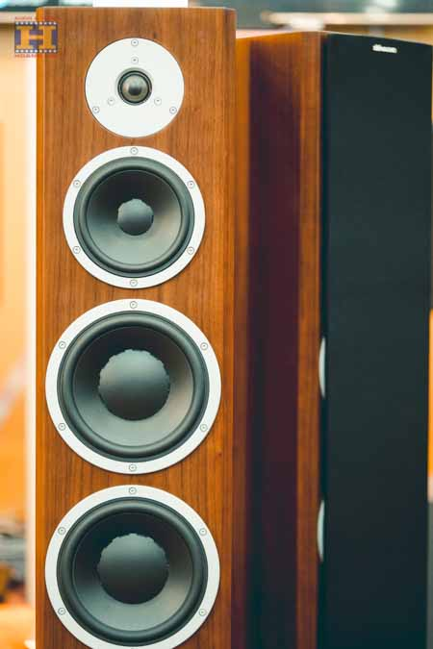

That's how the Excite X38 achieves resounding bass, superb dynamics and incredible control.

Good resolution and detail

The midrange driver also uses MSP, thus ensuring seamless integration with the woofer, while the fabric dome tweeter ensures the best resolution and high frequency detail. With meticulously selected cross components and optimized dispersion characteristics.

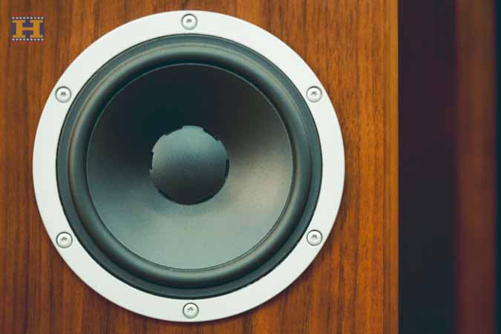

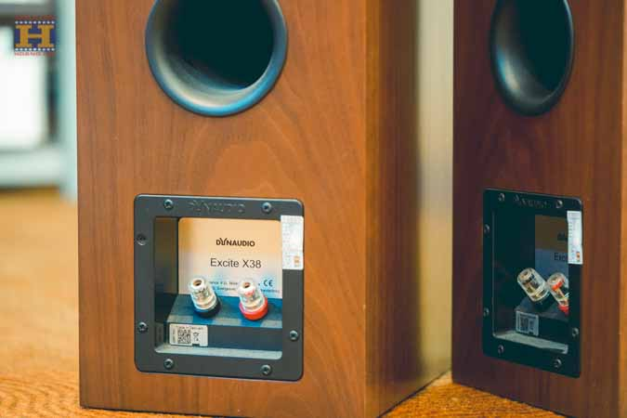

Integrated anti-resonance footrest

A notable feature is the integrated feet: depending on the floor, the Excite X38 can stand on four resonance-absorbing rubber feet or four height-adjustable spikes.

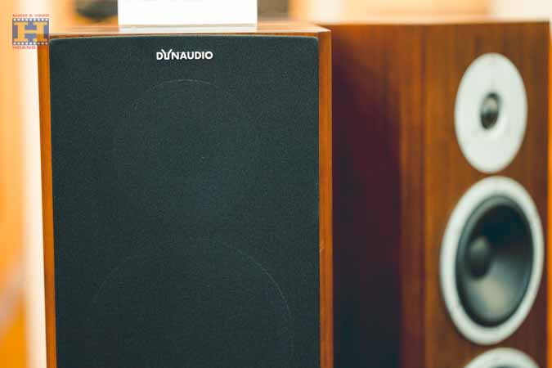

At Audio FOTOLAB, all products are imported genuine, customers will enjoy the manufacturer's warranty when purchasing.